**GARAGE MANAGEMENT SYSTEM**

**College Name:**Cheran College For Women

**College Code:** bru5g1

TEAM ID:NM2025TMID28626

TEAM MEMBERS:

Team LeaderName:S.Vaishnavi

Email:[vaishnavimarudhu@gmail.com](mailto:vaishnavimarudhu@gmail.com)

Team Membe:K.Swarnapriya

Email:[swarnapriyakarthi@gmail.com](mailto:swarnapriyakarthi@gmail.com)

Team Member: S.narmadha

Email:[narmadhan789@gmail.com](mailto:narmadhan789@gmail.com)

Team Member:P.S.MahaSakthi

Email:[mmahasakthi46@gmail.com](mailto:mmahasakthi46@gmail.com)

Team Member:K.KiranHabuk

Email:[srkathir0305@gmail.com](mailto:srkathir0305@gmail.com)

**INTRODUCTION**

**Project Overview**

The Garage Management System (GMS) built on Salesforce to streamline the management of customer details, vehicle service records, billing, and customer feedback. The project is designed to simplify operations for garages and service centers by improving customer management, enhancing service tracking, and ensuring efficient billing and reporting. Key features include customer data management, service scheduling, billing automation, and feedback collection.

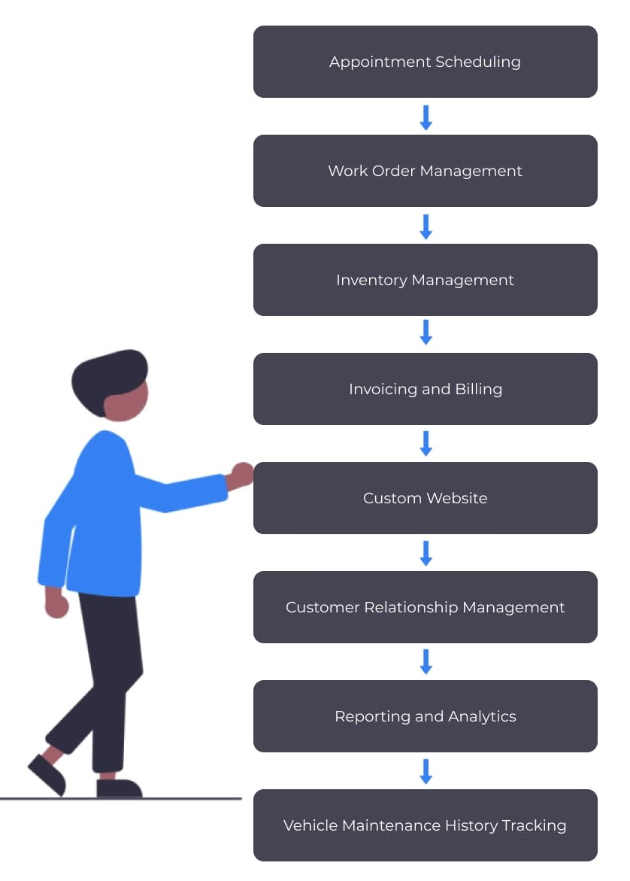

**Purpose**

The purpose of the Garage Management System is to digitize and automate garage operations. It helps in managing customer details, scheduling appointments, tracking service records, generating bills, and collecting feedback. This system saves time, reduces errors, and improves customer satisfaction**.**

**DEVELOPMENT PHASE**

**Creating Developer Account:**

By using this URL - [**https://www.salesforce.com/form/developer-signup/?d=pb**](https://www.salesforce.com/form/developer-signup/?d=pb)

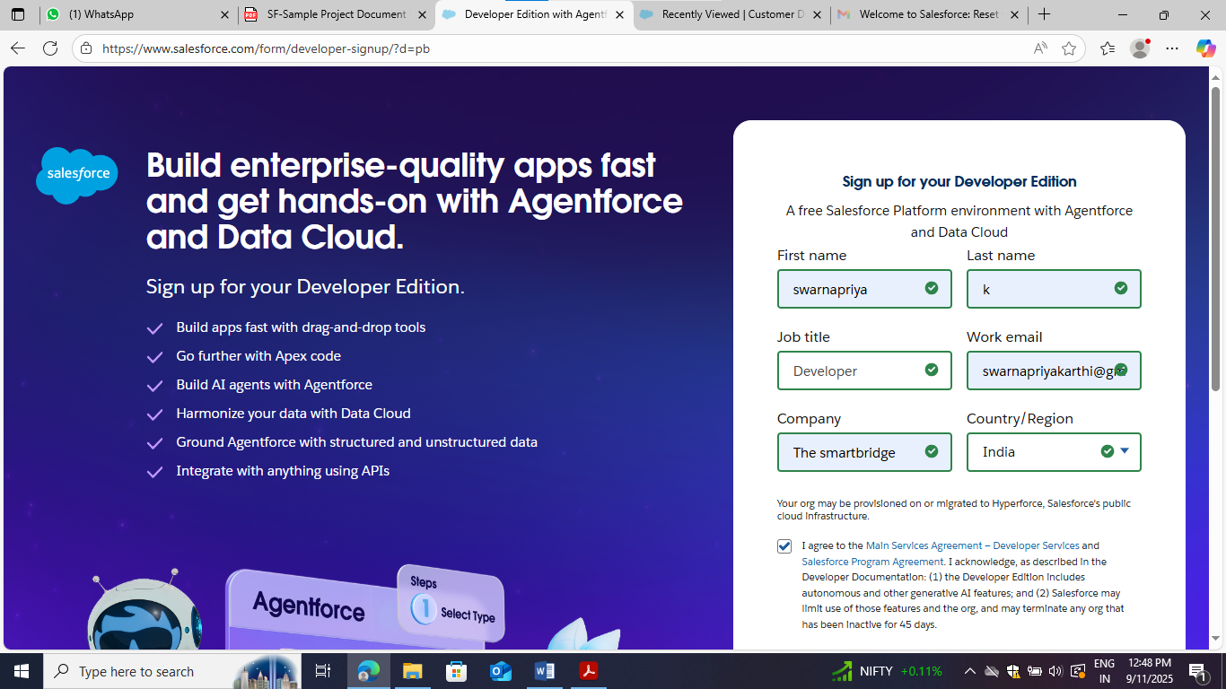

* Created objects : Customer details, Service records, Billing details and feedback,  Appointment

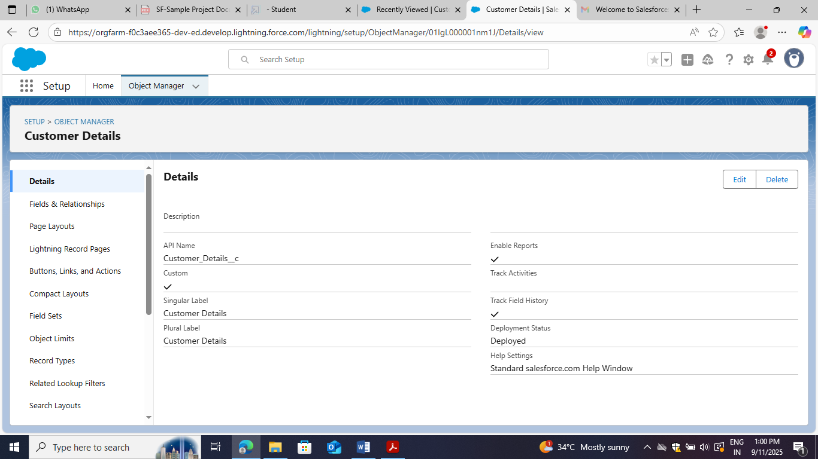

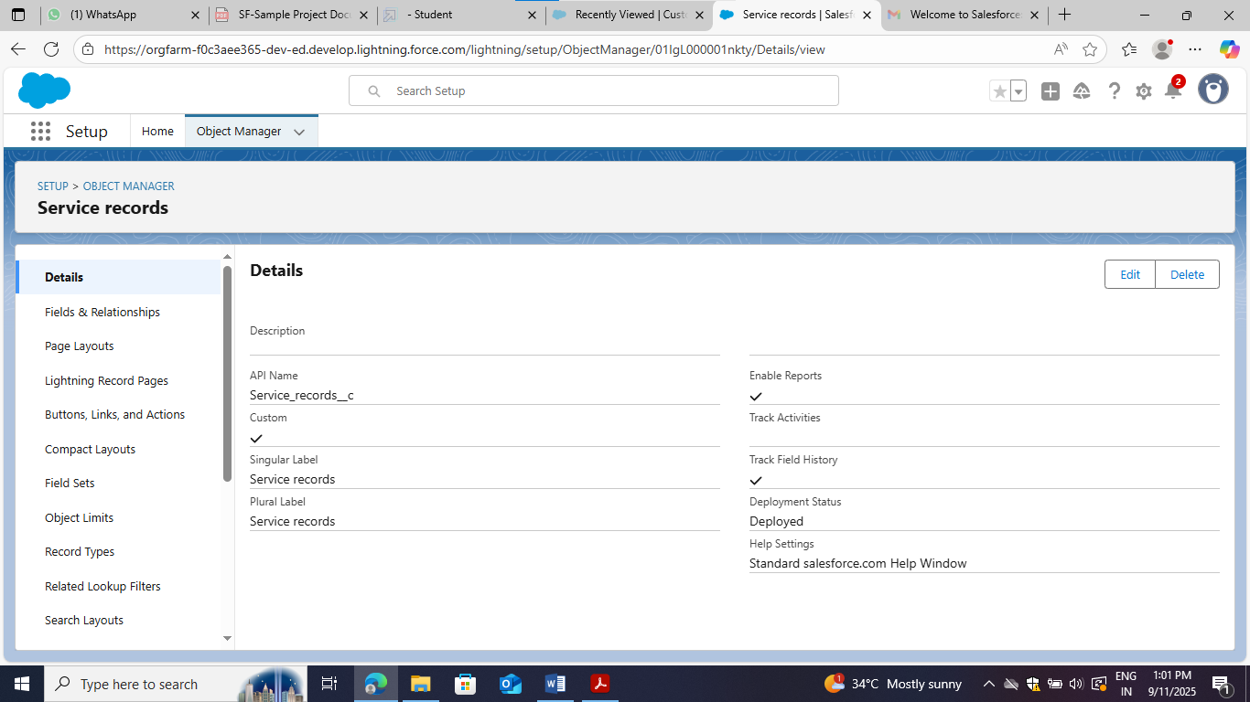

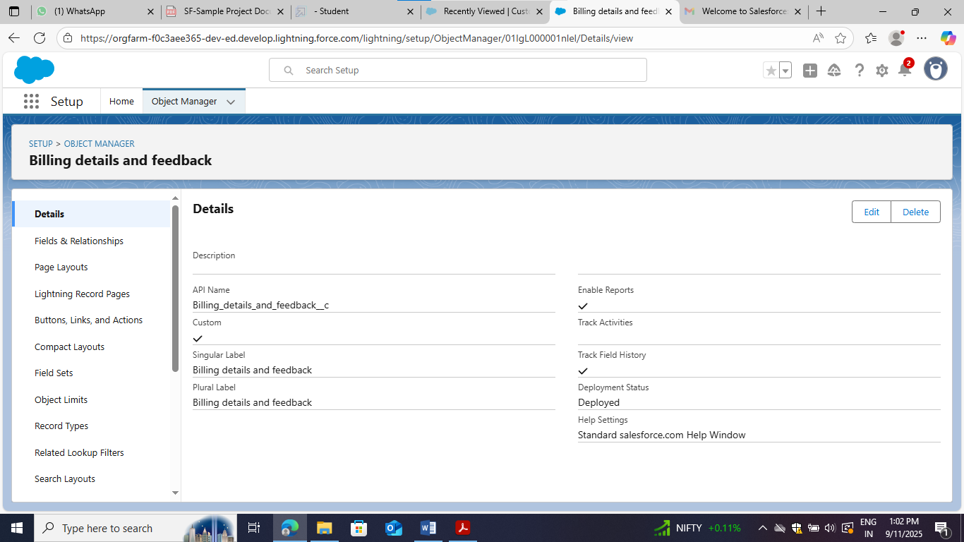

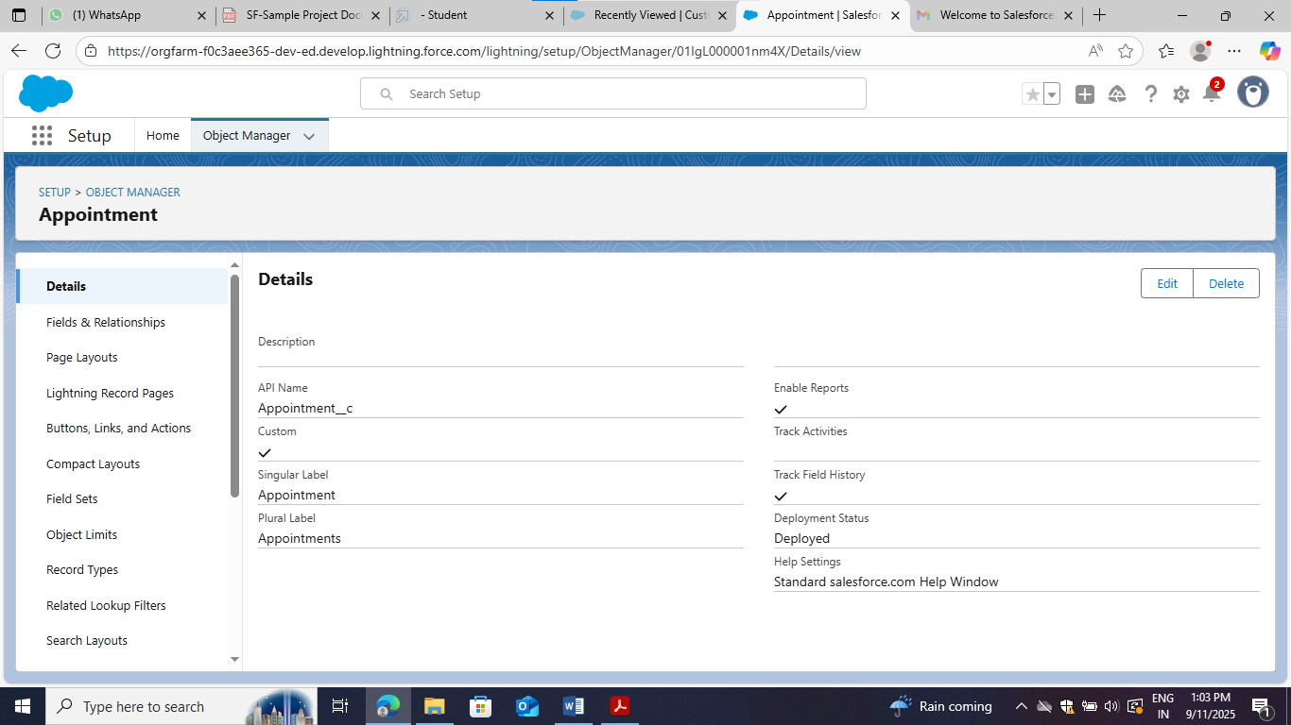

* Created Tabs : Customer details, Service records, Billing details and feedback,  Appointment

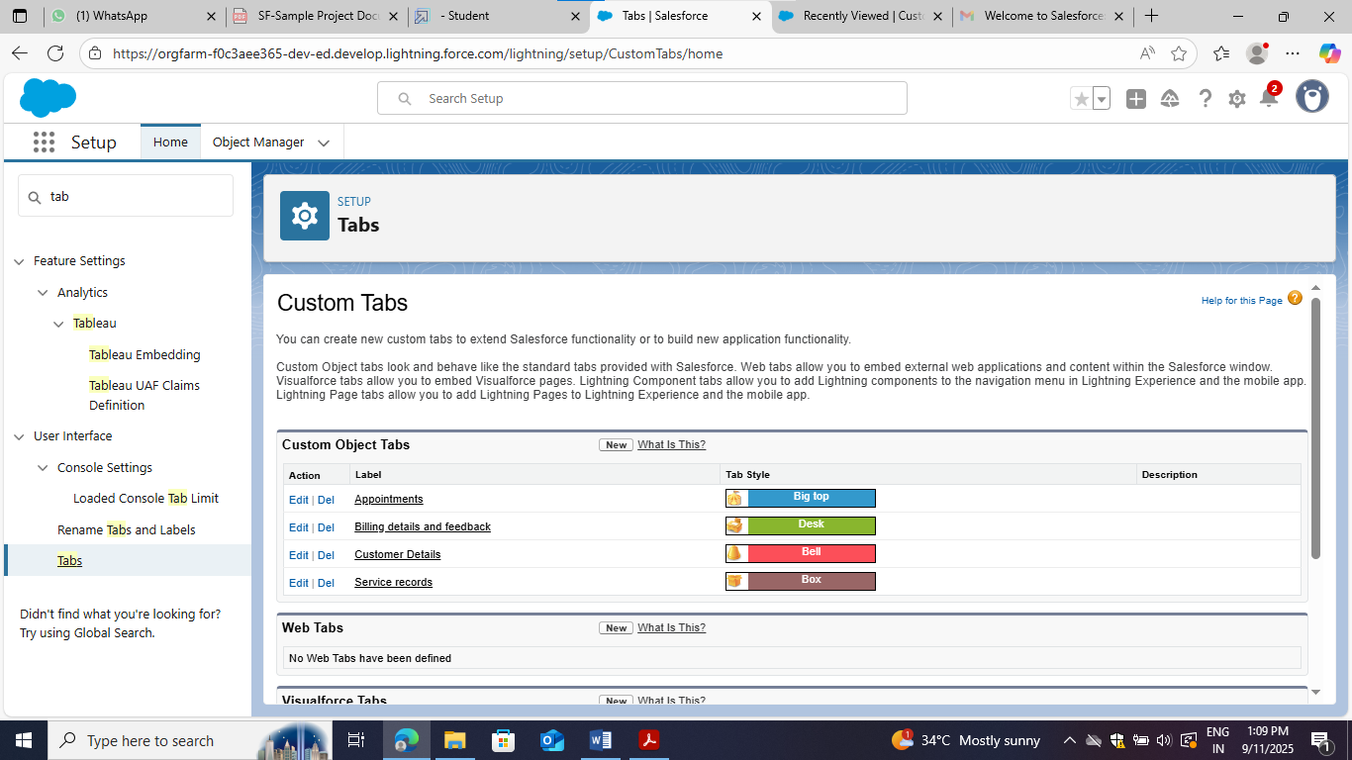

* Developed Lightning App

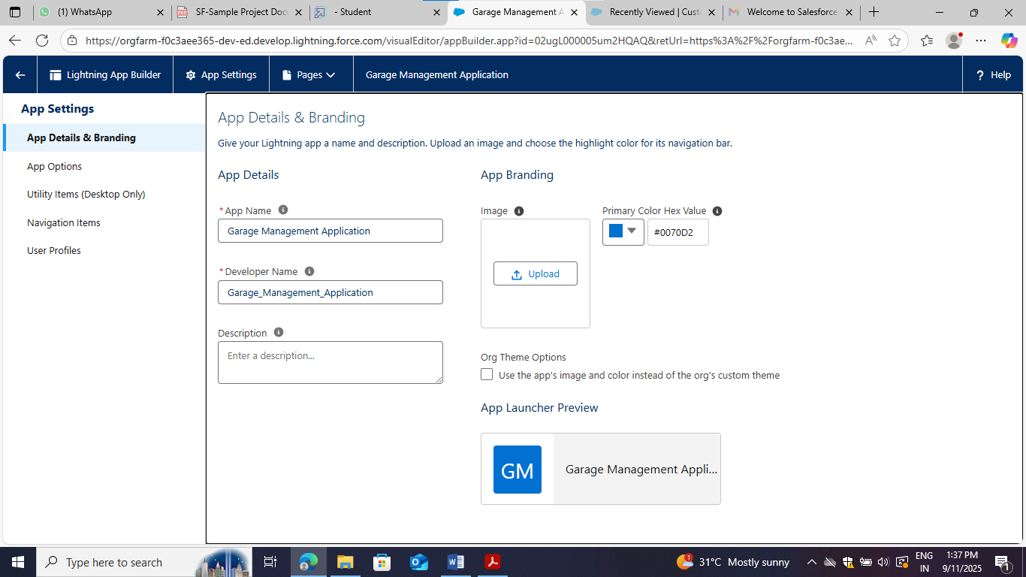

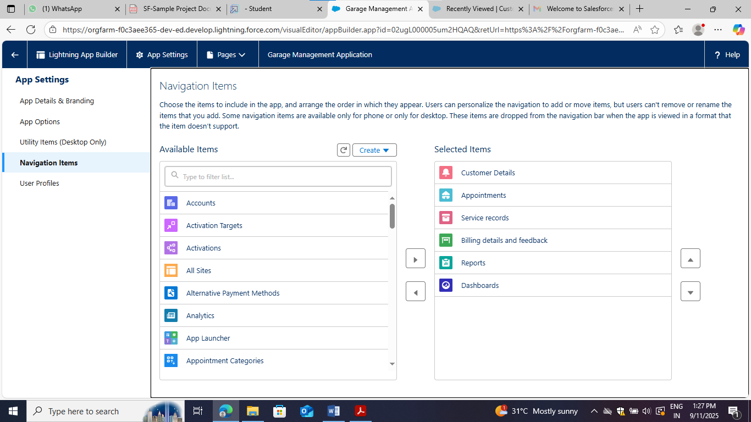

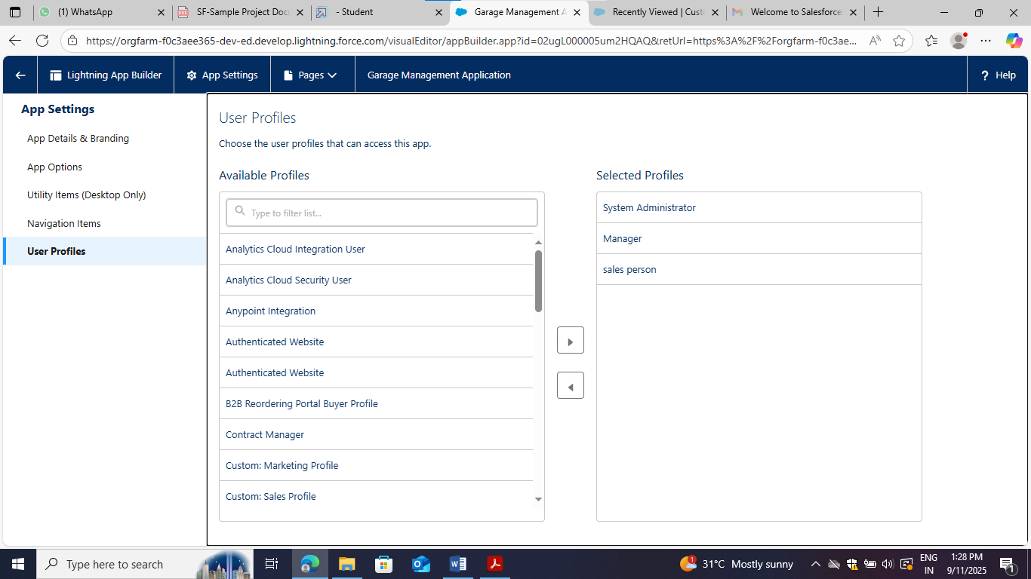

* Configured fields and relationships

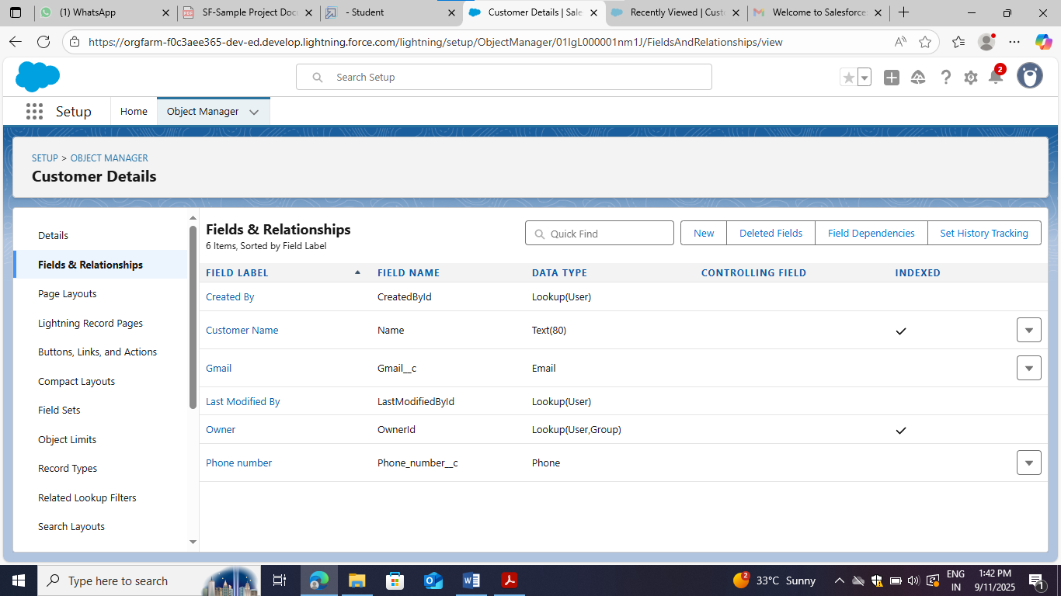

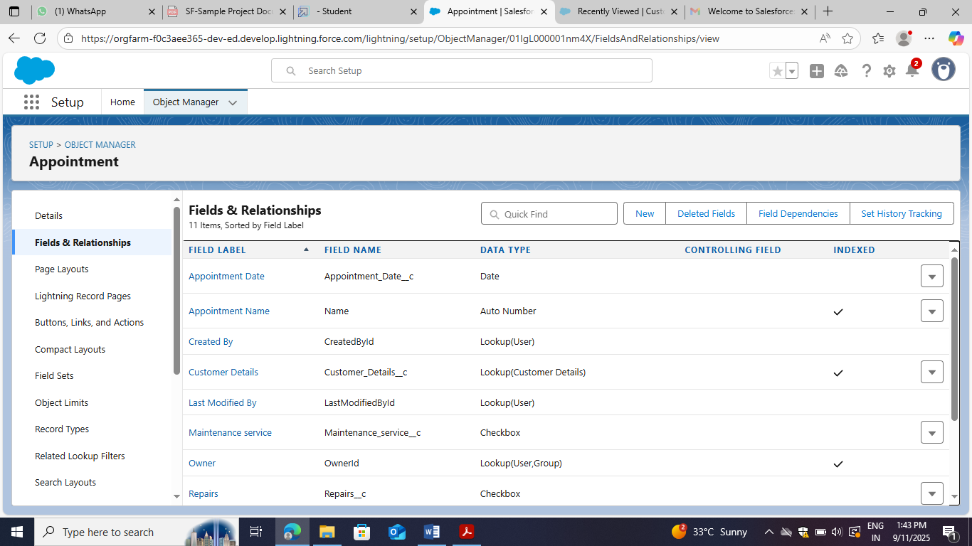

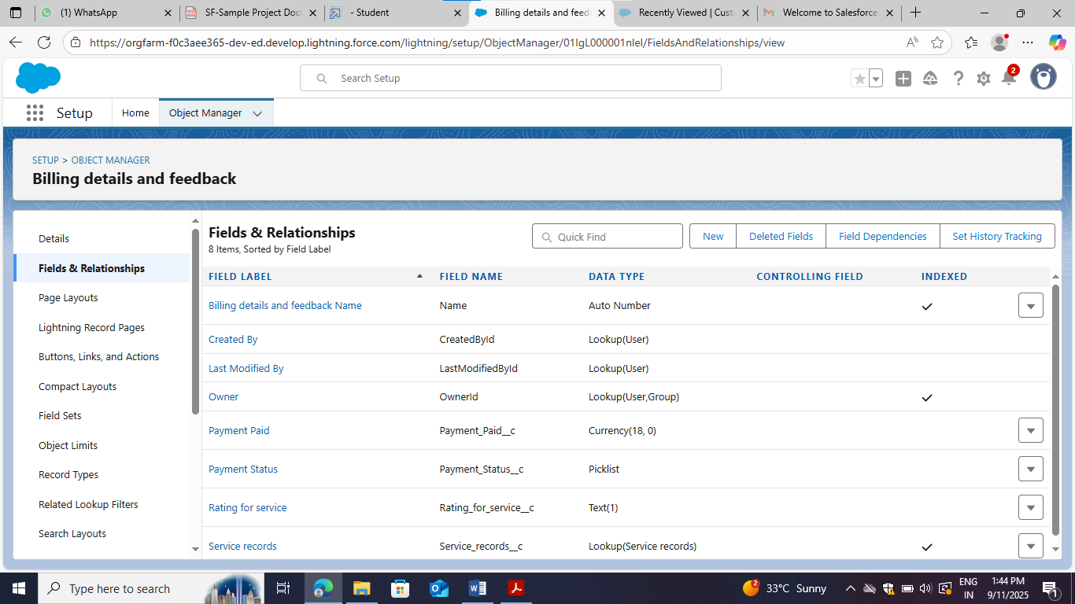

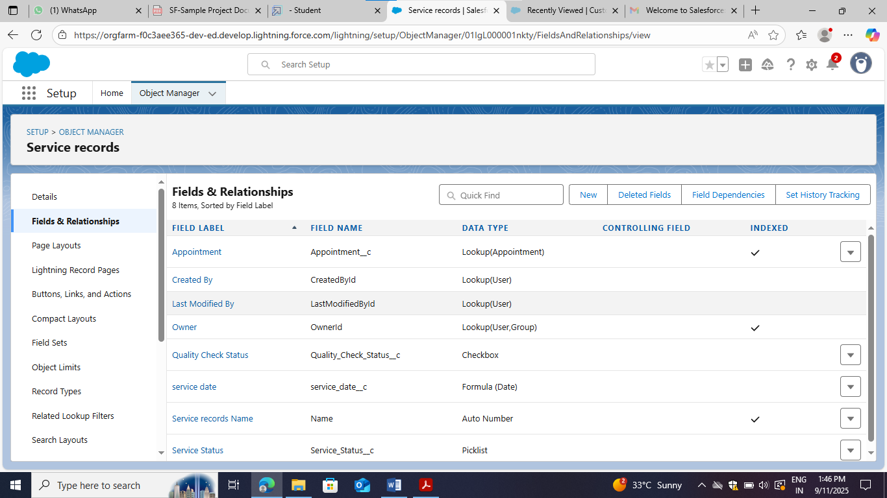

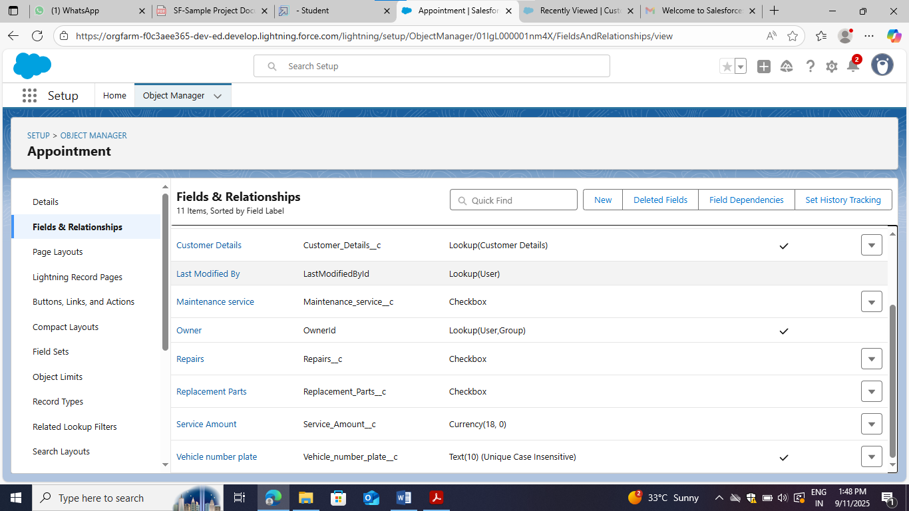

* Created a validation rule to an Appointment Object

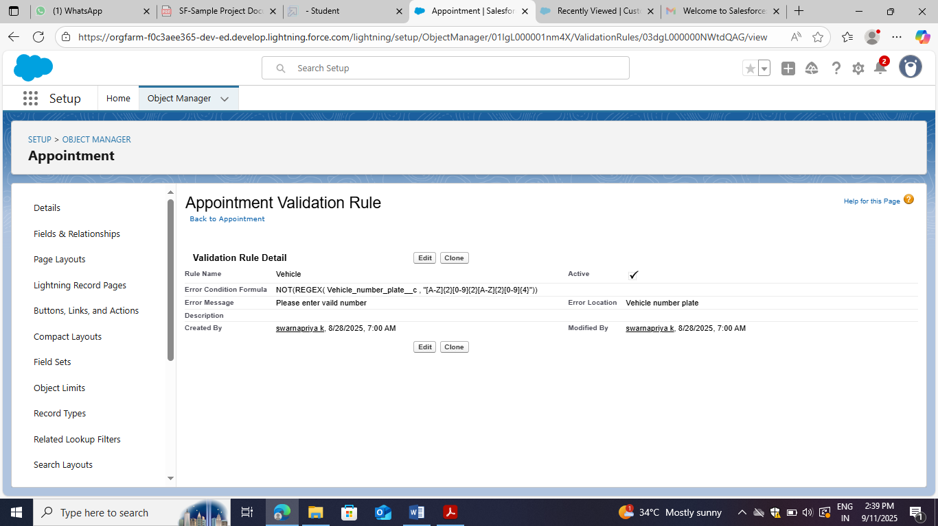

### Created a validation rule to an Billing details and feedback Object

### 

### Created a matching rule to an Customer details Object

### 

### Created a Duplicate rule to an Customer details Object

### 

### Created Manager Profile

### 

### Created sales person Profile

### 

### Created Manager Role

### 

### Created Sales Person Role

### 

### Created User

### 

### Created another users

### 

### Created New Public Group

### 

### Created Sharing settings

### 

### Created a Flow

### 

### 

### Created another Flow

### 

### 

### Apex handler

### Created new apex class(AmountDistributionHandler)

### 

### 

### Created a new trigger

### 

### 

### Created a report folder

### 

### Sharing a report folder

### 

### Created Report Type

### 

### 

### Created Report

### 

### 

### Created Dashboard Folder

### 

### Create Dashboard

### 

### 

### 

### Created records

### 

### 

### 

### Conclusion :

### The Garage Management System successfully automates garage operations by digitizing customer, service, and billing workflows. It provides an efficient, scalable, and user-friendly solution to improve customer experience and operational performance. Future enhancements like chatbot and AI integration will further enhance customer engagement and business efficiency.